Internal Quality Assurance Cell
ANNUAL ACTION TAKEN REPORT 2023-34
Career guidance courses were hosted by Dept of Marathi and English
Health and Wellness certificate course was implemented by Dept of Zoology
Certificate course for English was continued to help student prepare for Entrepreneur skills
The institute focused on enrolling more students to Career Katta for better preparation of competitive exams.
FDP was conducted for non teaching staff’s skill upliftment
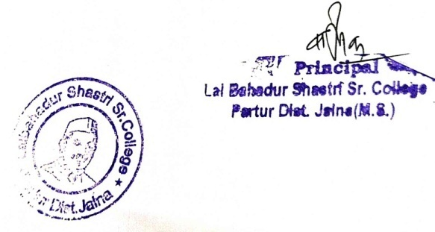

Internal Quality Assurance Cell
ANNUAL ACTION TAKEN REPORT 2020-21
Year 2020-21 adhere strictly to online classes, even though a small period of break was taken in between. Principal instructed all the teaching staff to conduct the classes and complete the syllabus.
Along with the academic activity Principal advice all the member to keep research work active and involve the students also. In Pursuance of IQAC meeting following actions were taken:
Academic calendar for academic session was prepared and approved by the principal
College magazine book for the academic year was edited by the Editorial Board and was published and released in Covid restrictions.

In Pursuance of the IInd IQAC meeting the following actions were taken:
Uniform format for monthly teaching report was framed and adopted.
Feedback on curriculum was collected from alumni, students and parents via google form.
The analysis of the report has been reviewed by the principal
In pursuance of the IQAC meeting, two Days Faculty development programme for teaching and non-teaching was conducted.
Feedback format prepared for 2021 -22 sessions.

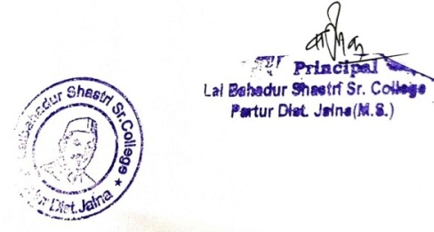

Internal Quality Assurance Cell
ANNUAL ACTION TAKEN REPORT 2019-20

Workshops were conducted for teachers to facilitate the use of ICT tools, online teaching via video conferencing and e-materials.
Teachers also use different student centric methods for teaching learning such as Video conferencing like Zoom. E-resources are also increased in the library for enhanced leaning of students.
Study material and related links of competitive exams along with e-books were also shared with students via Telegram.
Our Institution also envisions to strengthen the interest of the students in sports. Ground facilities are made available throughout the college time to students.
The institute ensures an eco-friendly campus for students. The students also participate in tree plantation to greenify the campus. Water conservation plant is also installed in the campus.
Led tubes are installed to decrease energy consumption

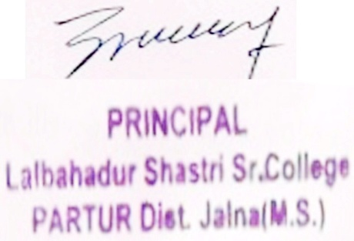

Internal Quality Assurance Cell
ANNUAL ACTION TAKEN REPORT 2018-19

The Academic Calendar was prepared and executed accordingly
Yoga camp was hosted by the institute
IQAC checked the API scores of the faculty members.

